Data Visualizations of Fruit Prices

Santhosh Kumar Suresh Kumar  
Santhoshkumarsures@lewisu.edu  
DATA-53000, Fall 2024

Data Visualization Lewis University

# Introduction

The data under analysis comes from "ALL FRUITS – Average Prices" dataset, which offers a comprehensive look at pricing across the fruit market. This extensive collection includes pricing information for traditional fresh fruits such as apples, oranges, and watermelons, alongside various berries and seasonal offerings. What makes this dataset particularly valuable is its coverage of different product forms: canned fruits preserved in syrup or juice, liquid products including pure fruit juices and concentrates, frozen items ranging from individual quick-frozen fruits to mixed varieties, and dried products including dehydrated and sun-dried options. The dataset's broad scope allows for a thorough examination of how prices vary not only between different types of fruits but also across different processing and preservation methods, providing valuable insights into the pricing dynamics of both fresh and processed fruit products in the market.

# Data Description

As described in Section I above, The dataset captures detailed pricing and measurement information across various fruits and their forms in the market. The dataset uses key attributes such as 'Fruit Form' (fresh, canned, frozen, dried, or liquid), 'RetailPrice' with its measurement unit, and 'Yield' showing usable portions. For standardized comparison, it includes 'CupEquivalentSize' and 'CupEquivalentPrice' attributes. This structured data reveals interesting price variations - fresh berries typically command higher prices than traditional fruits like apples and oranges, while processed forms such as frozen or dried fruits show different pricing patterns. Canned fruits often prove more economical than their fresh counterparts, while specialty fruit juices and concentrates demonstrate premium pricing. The comparison between organic and conventional fruits also shows consistent price differentials, with organic options generally commanding higher retail prices. This comprehensive price analysis helps understand market valuations across different fruit types and their various processed forms.

1. Data Attributes

| **Attribute** | **Type** | **Example Value** | **Description** |
| --- | --- | --- | --- |
| Fruit | Categorical | Apple | Types of Fruits |
| Form | Categorical | Fresh | The State of the Fruit in which it is used |
| Retail Price | Numeric | 1.5 | Price of Fruits |
| Retail Price Unit | Categorical | Per Pound | The unit used for weighing the fruits |
| Yield | Numeric | 1 | Total yield of the fruits |
| Cup Equivalent size | Numeric | 8 | Size of the cups used for juice |
| Cup Equivalent Unit | Categorical | Fluid Ounces | The unit used to measure the cup |
| Cup Equivalent Price | Numeric | 1.2 | Price of cups |

# Methodology and results

The data was input into Tableau, and multiple visualizations were created to conduct exploratory visualizations on the data. Figure 1, titled "Retail Price vs Fruit", shows the pricing of different fruits, where each fruit is priced based on its demand in the market. Every fruit has its own unique pricing, with raspberries taking the highest price at $13.7, and watermelon having the lowest price at $0.4. This demonstrates the wide variation in fruit prices, influenced by factors such as demand, availability, and market trends.

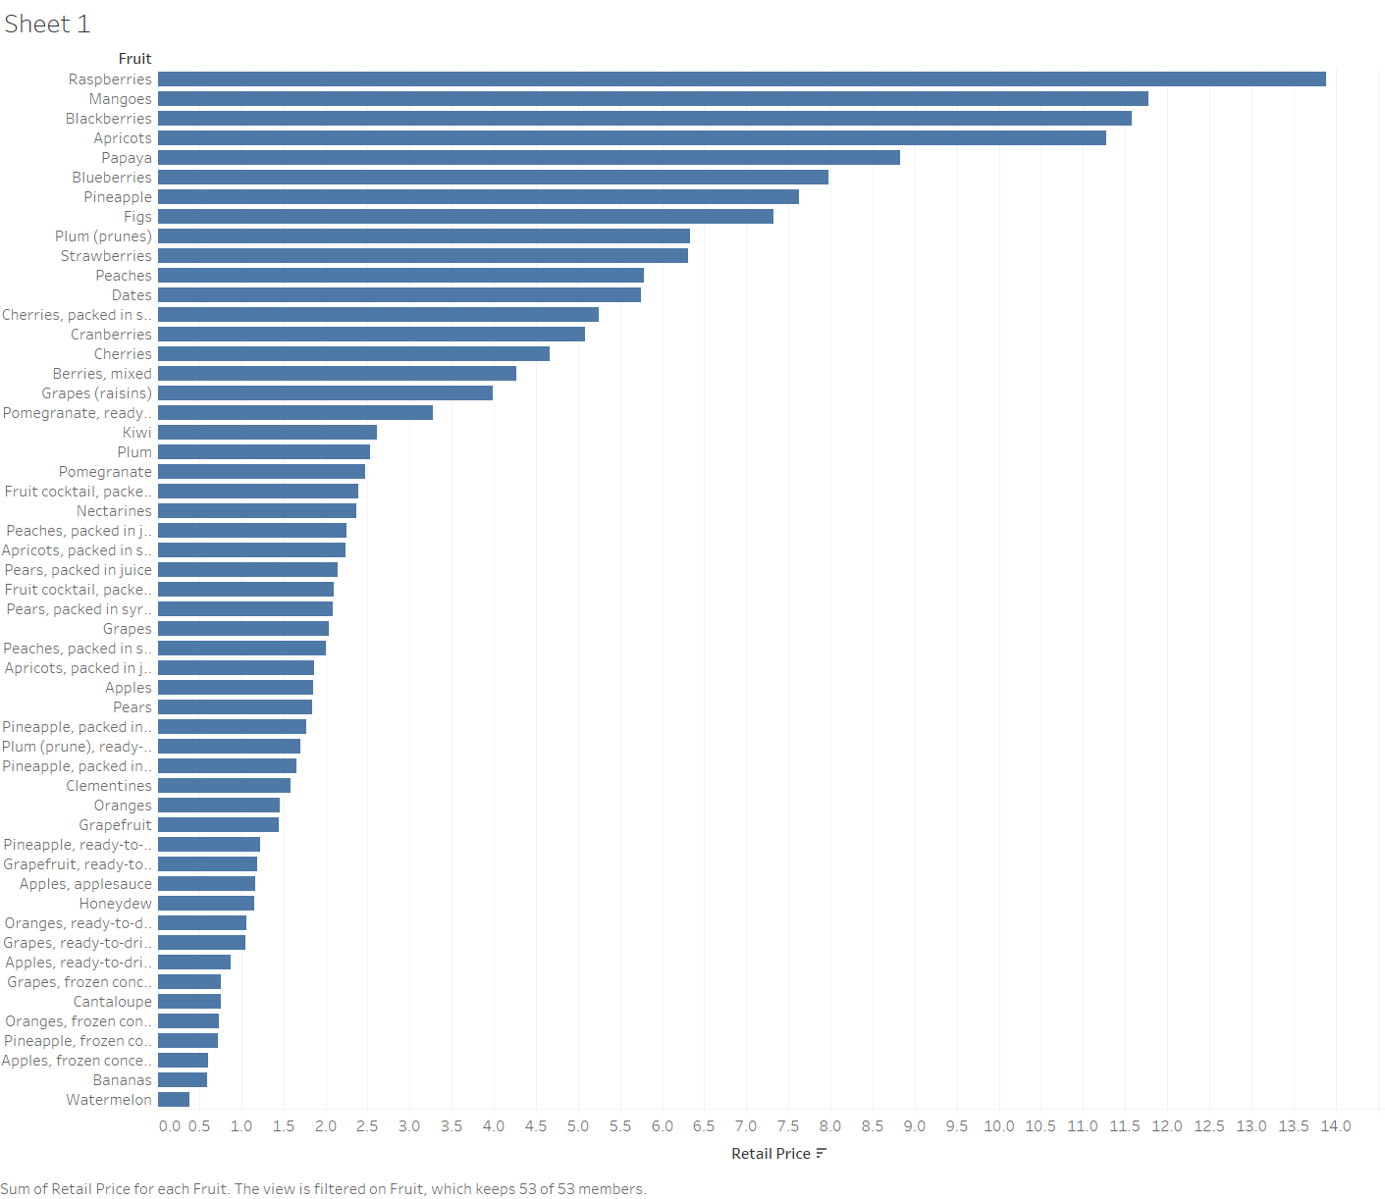

Fig. 1 Retail Price vs Fruit

Figure 2 provides a visualization of "Total Yields vs Form of Fruit", highlighting the most frequently purchased forms of fruit. It clearly shows that fresh fruits dominate with the highest yield at 19, while canned, dried, and juice forms are relatively similar, ranging between 12 and 8. The least popular form, with the lowest yield, is frozen fruits. This visual representation emphasizes consumer preferences for fresh fruit over processed or preserved forms.

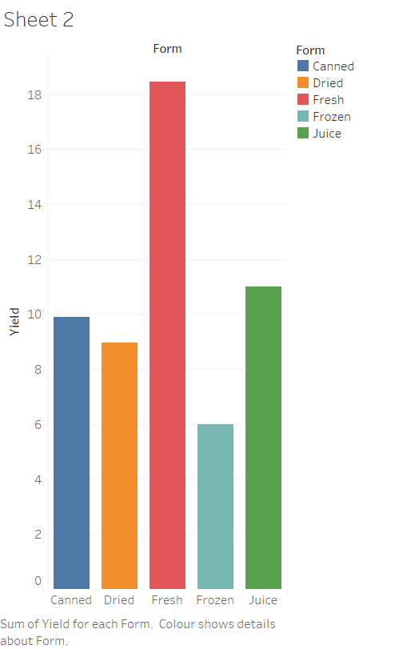

Fig. 2 Total Yield vs Form of Fruit

Figure 3, titled "Total Yields of Fruits", employs visualization techniques to display the individual yields of various fruits. The image clearly indicates that fruits such as strawberries, raspberries, apricots, pineapples, blueberries, peaches, and mangoes have the highest yields, reflecting their popularity and consumer demand. In contrast, fruits like apples, figs, dates, and kiwis show lower yields, suggesting they may be less favored in the market. This visual representation allows for a straightforward comparison of fruit yields, highlighting the disparity between the most and least abundant varieties. Understanding these trends can aid in inventory management and marketing strategies for fruit producers and retailers alike.

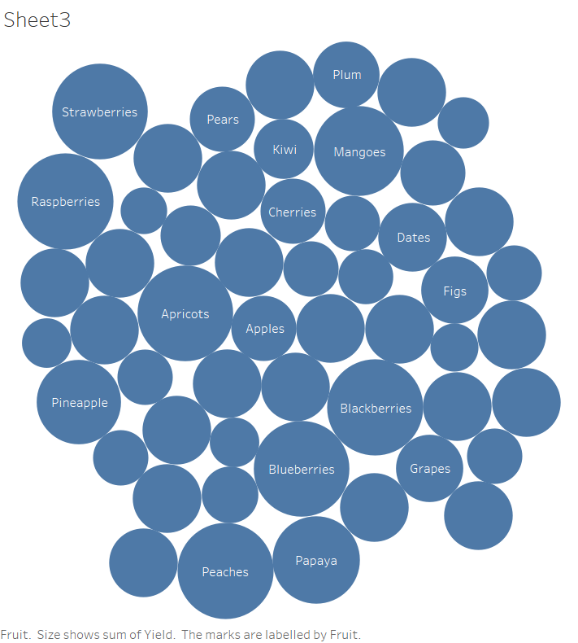

Fig. 3 Total yields of Fruits

Figure 4 illustrates the "Cup Equivalent Price vs Fluid Ounces and Pounds", showcasing the relationship between the average price of various fruits and their corresponding cup size. This visualization provides insights into the average cost per cup for different forms of fruits, including fresh, juice, dried, and canned options. It highlights the comparison between the pricing and the average size of a cup, allowing for a clear understanding of how the form and quantity of fruit impact its cost.

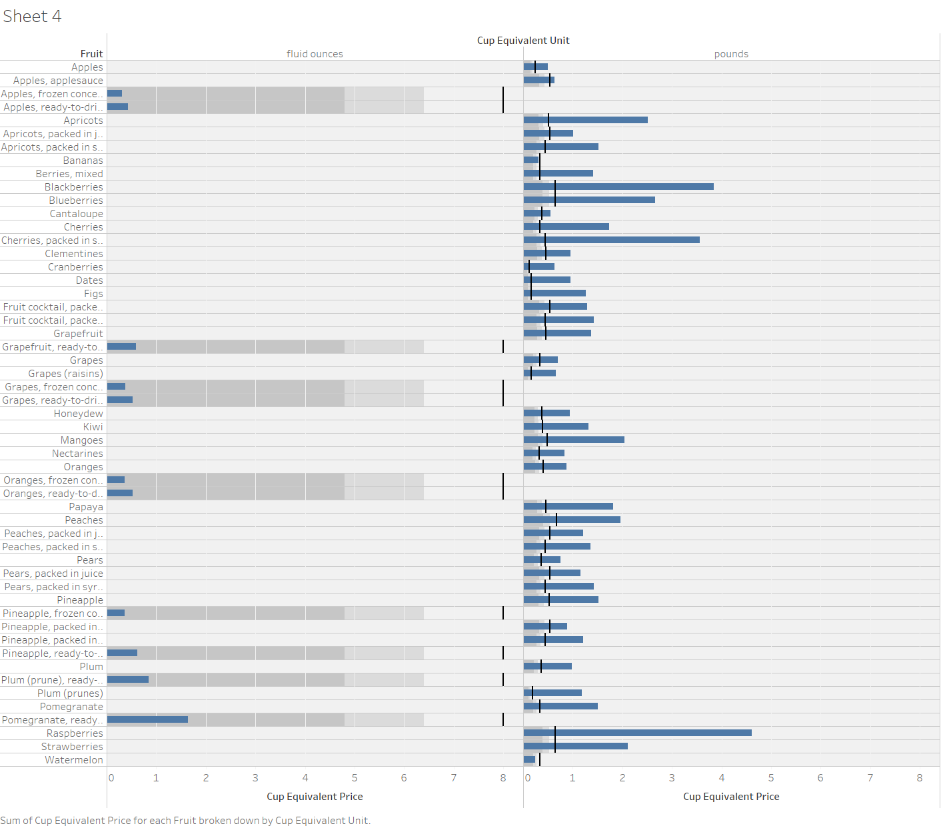

Fig. 4 Cup Equivalent Price vs fluid ounces and pound

Figure 5 presents a visualization of the "Price of All Fruits by Form Sold," offering insights into the most sold fruit forms and their respective prices. This data enables us to predict which fruit forms are in highest demand and which command higher prices. By analyzing this information, businesses can focus on increasing the quantity of high-demand, high-priced fruits for the next sales cycle, optimizing their inventory and sales strategies.

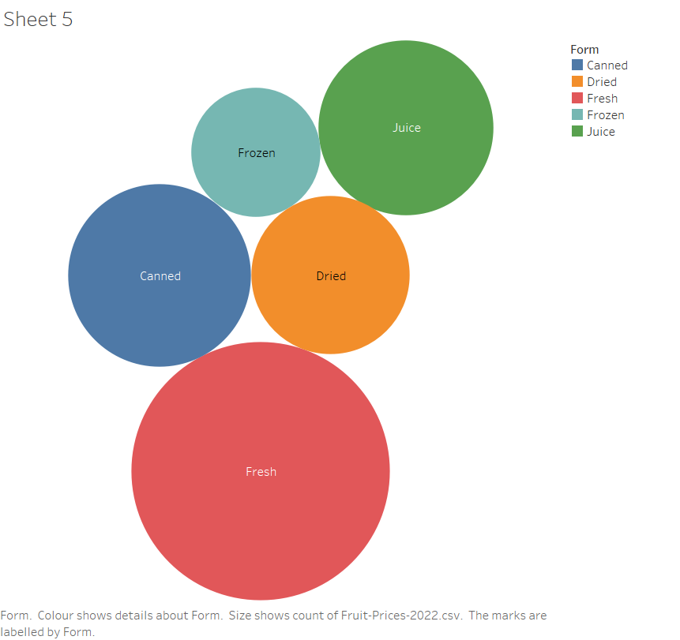

Fig. 5 prices of fruits in their forms

# Discussion

The "ALL FRUITS – Average Prices" dataset, sourced from the U.S. government website, provides an insightful look into fruit pricing and yields across different forms. The visualizations created from this dataset reveal key trends in the fruit market. For example, Figure 1 highlights the price variation between fruits, where raspberries are the most expensive, and watermelon is the least expensive, reflecting their demand and supply factors. Figure 2 emphasizes the consumer preference for fresh fruits, which consistently have the highest yields, while processed forms like canned, dried, and juice show stable but lower yields.Figure 3 gives a detailed comparison of individual fruit yields, showing that fruits like strawberries, raspberries, and pineapples dominate in terms of yield, indicating their popularity, while fruits such as apples and kiwis have lower yields. This information is vital for managing inventory and forecasting demand. Figure 4 illustrates the relationship between cup size, fluid ounces, and fruit prices, helping to identify cost differences between various fruit forms, particularly between fresh and processed options.Figure 5 adds another layer by showing the price of all fruits by their form, which enables businesses to predict the most sold fruit forms and identify those with higher prices. This information allows producers and retailers to adjust their focus on high-demand, high-priced fruits and plan for increased production in future sales cycles.

Overall, these visualizations provide a comprehensive understanding of fruit market trends, allowing for more informed decisions related to pricing, inventory management, and market strategy to meet consumer demand effectively.

# Conclusions

##### This analysis of the "ALL FRUITS – Average Prices" dataset, sourced from the U.S. government, provides valuable insights into fruit pricing, yields, and market trends. Through various visualizations, we observed significant price differences across fruits, with raspberries being the most expensive and watermelon the least. Fresh fruits consistently showed higher yields, reflecting consumer preference, while processed forms like canned and dried fruits maintained steady demand. The relationship between cup size and price further highlighted cost variations by fruit form. Additionally, by analyzing the pricing of fruits by form, we can predict which fruits are most sold and which command higher prices, allowing businesses to adjust their focus on high-demand, high-priced fruits. These insights offer practical strategies for optimizing inventory, pricing, and production in future sales cycles.

##### References

[1] **“**ALL FRUITS – Average Prices Data”**,** 23rd May 2024 | [Online] <https://www.ers.usda.gov/data-products/fruit-and-vegetable-prices.aspx>